Using Alfresco Zimlet

Overview

Alfresco Zimlet Package provides integration between Zimbra Collaboration Suite and Alfresco Enterprise Content Management (ECM) using Zimbra Zimlet technology, Alfresco Webscript technology and Yahoo YUI Javascript library.
Its key functionalities include
- Allowing user to manage Alfresco ECM server location and credentials as Zimlet preferences and managing security seamlessly.
- Allowing user to save attachments of incoming emails to Alfresco ECM server.
- Allowing user to select multiple documents from Alfresco ECM server and then attach them to outgoing emails.
- Allowing user to download documents from Alfresco ECM server or paste links to Alfresco documents directly into outgoing email body.
- Providing easy-to-use widgets for users to select Alfresco space or navigate through Alfresco repository.

Installation and Configuration

This integration package requires pre-installation of Zimbra Collaboration Suite (Version 5.0.6 or later) and Alfresco Enterprise Content Management (Version 2.1 or later). Once the package is installed, user need to provide location of Alfresco ECM server as well as user name and password for the Alfresco ECM server.
For more information regards to installation, configuration and validation, please refer to the “Alfresco Zimlet Installation Guide” document.

How to Use Alfresco Zimlet

Saving Email Attachments to Alfresco ECM Server

The Alfresco Zimlet provides an additional attachment handler which renders “save to alfresco” link for each attachment of incoming emails. Users can simply click on the link and it will pops up a dialog asking for Title ( Pre-populated with the original file name of the attachment), Description (Optional input field) and Path of the Space where the attachment will be stored inside Alfresco ECM server.
The Space Path input field is an auto-complete style widget. Based on the user input, it will automatically generate a list of valid selections of Alfresco space paths for user to choose.
To start with root path of Alfresco ECM server, user can simple type / . If user prefers to start the browsing from his/her own home space, ~ is the character user needs to type.
Once user selects or types a space path and wants to continue exploring its subspaces, he/she can simple type / and the widget will show the list of paths of the subspaces.
Once all inputs are provided, click “Ok” button to save the attachment to Alfresco ECM server. The zimlet will first show the progress dialog and then the status dialog.

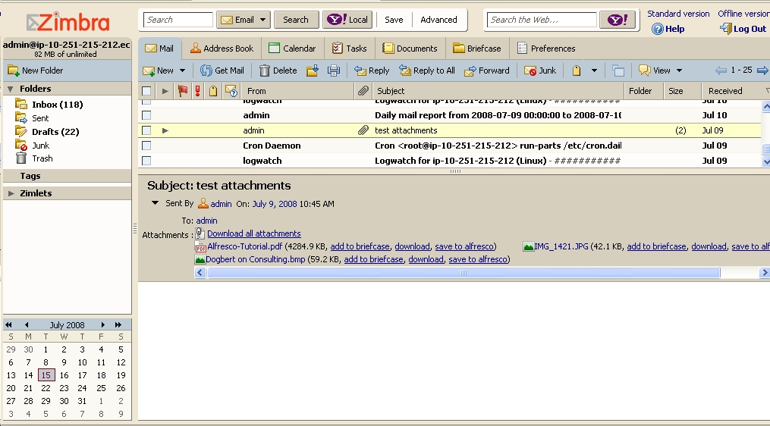
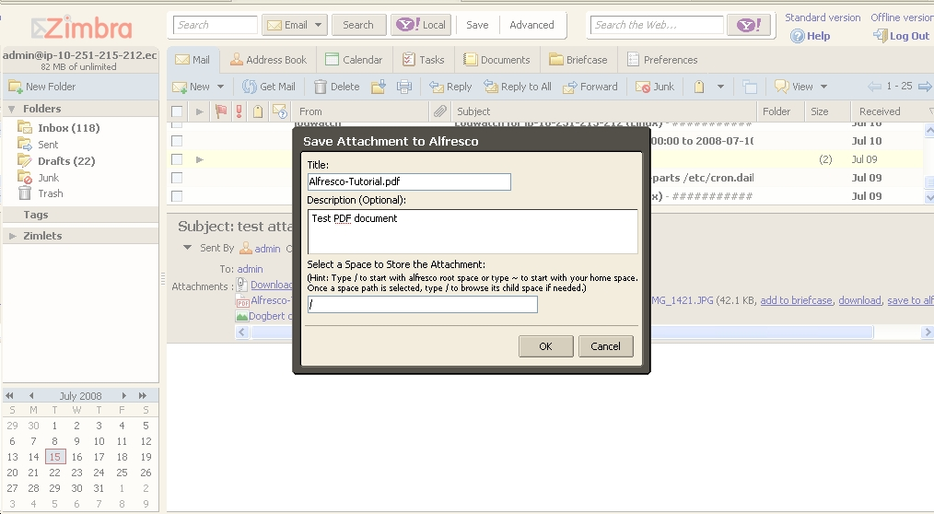

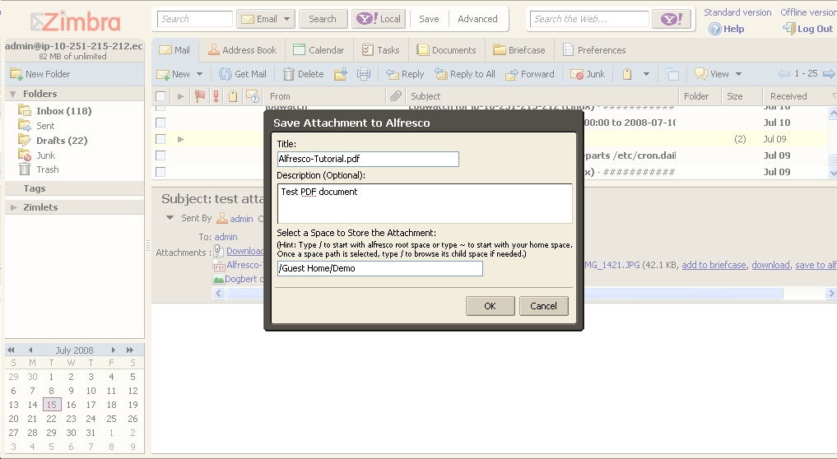
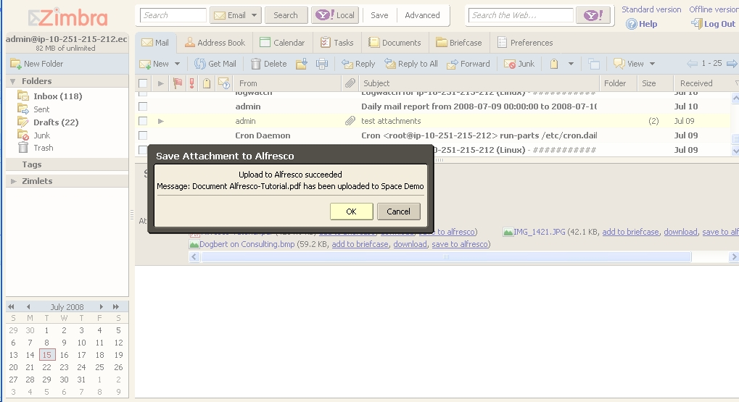

Attaching Alfresco Documents to Email

The Alfresco Zimlet provides an additional tab on the “Add Attachment” dialog for users to select Alfresco documents and attach them to the outgoing email.
First, click “Add Attachment” button and then click “Alfresco Documents” tab on the pop-up dialog. It will show the root space of the configured Alfresco ECM server. Click on the “+” icon to expand the corresponding space or the “-” icon to collapse the space if it has been expanded.
All nodes of the navigation tree will have a checkbox in front of it. If user decides to select the document or the space, he/she can simple check the checkbox. Move the mouse over the node and a tool tip will pop-up with information regards to the description, author and size of the document if applies.
Please note that if a space is selected, all the documents under the space or its subspaces will be selected as well. However, since the tree is generated in an on-demand fashion, only the document nodes that have been viewed (its parent space has been expanded or collapsed) will be selected.
Every time a document or space node is selected, a pop-up dialog will show the current selection as a list with document name, path and links for downloading and pasting short link of the document. After reviewing the selections, user can then proceed to attach the documents by clicking “Ok” button to close the “Document Selections” dialog and then clicking the “Attach” button on the “Add Attachment” dialog. Wait till the progress dialog disappears, user should see the selections of Alfresco documents have been attached to the email.

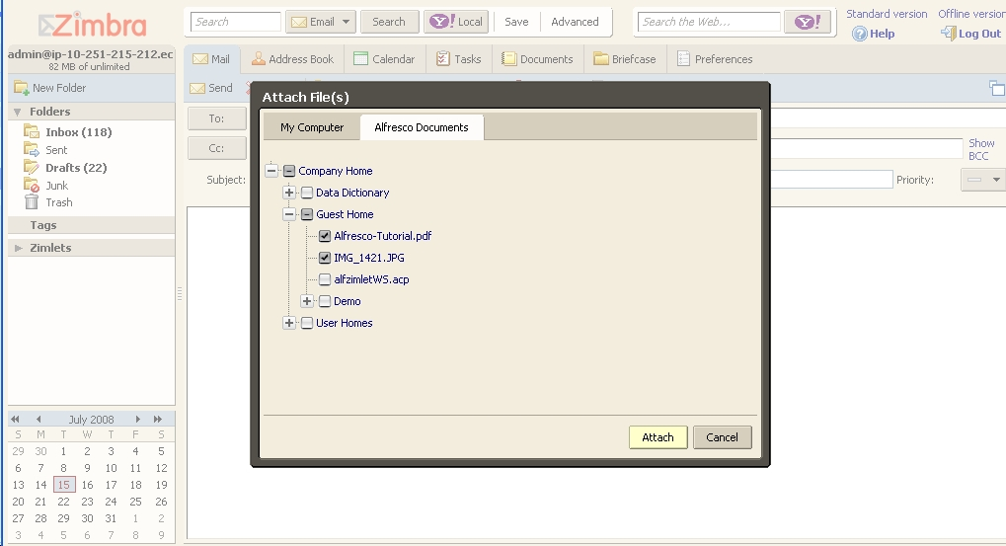

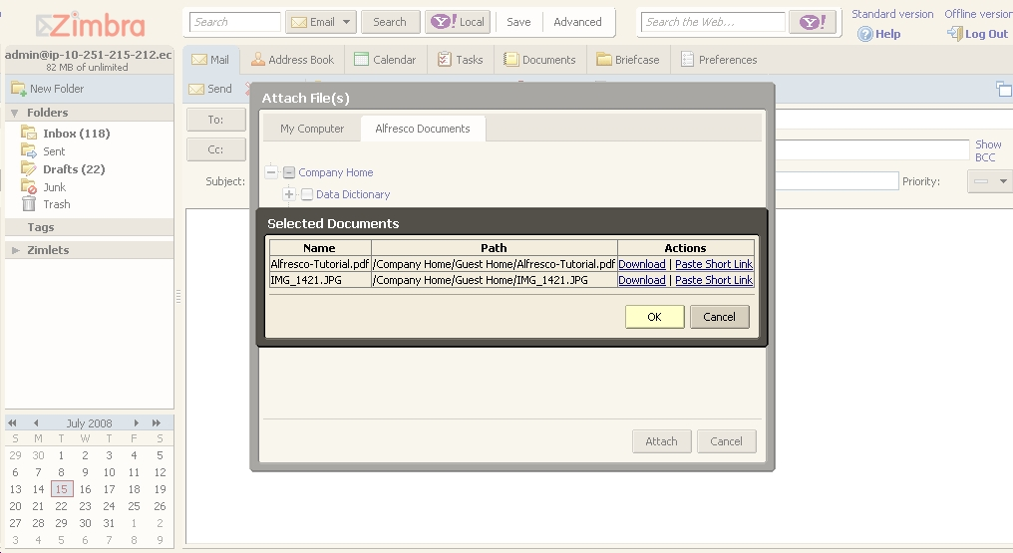
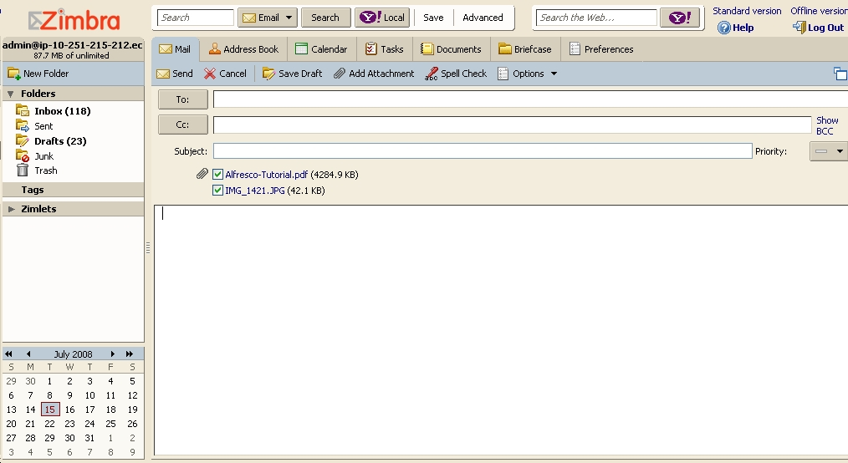

Pasting Short Link of Alfresco Documents to Email

Instead of attaching Alfresco documents to the email as physical files, this zimlet also allows users to paste the short links of selected Alfresco documents directly into the email body. When the recipients of the email read the email, they can simply click the links to download the documents.
To paste the link, user can click on the “paste short link” links on the “Document Selections” dialog when the documents are selected.
A typical short link looks like
<a href='http://zimbra.alfrescolabs.com:8080/alfresco/wcs/d/364'>Alfresco-Tutorial.pdf</a>

